Personal learning and Work Log - Saviero Shioru Dimulia

2026-10-21
We read and tried to understand what we needed to do in the shared project rules. After that we decided on our roles, as a CTO, I got straight into working on the github repository. I had little experience on github, so, I searched up how to make a repository, how to add people to repository, etc (https://docs.github.com/en/repositories/managing-your-repositorys-settings-and-features/repository-access-and-collaboration/inviting-collaborators-to-a-personal-repository).
After that I messed around with github to understand how to upload files, make branches, delete branches/files, etc (Ex.1.1). I then made a document teaching my team members how to use github.
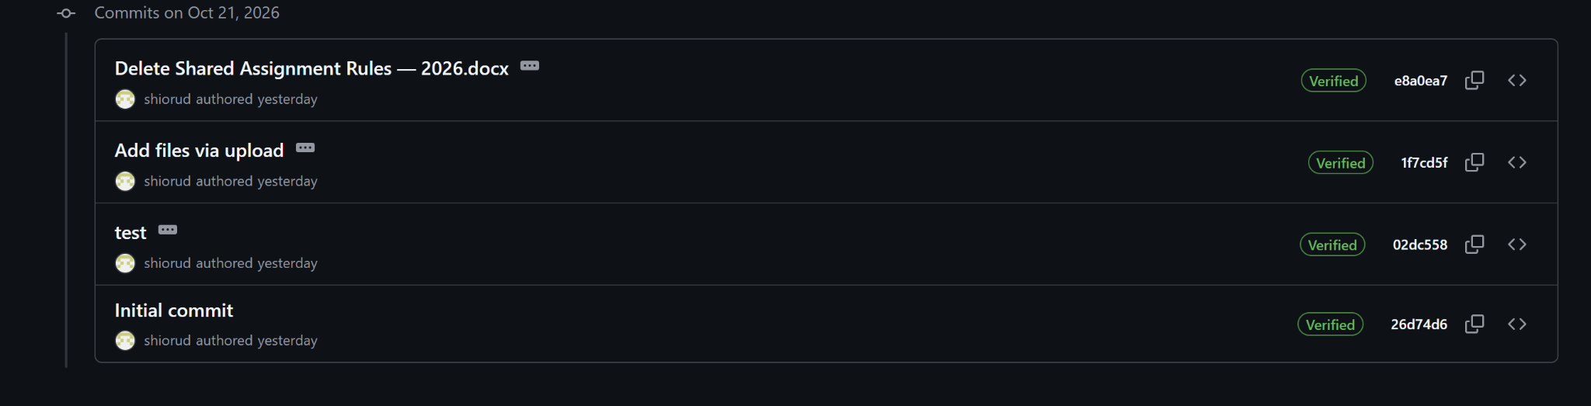
Ex.1.1

2026-10-(22-23)
Made the read me file on github, added each member’s username and project topic(Ex.2.1). Recommended our tester to use an efficient flowchart maker. Also made workspace branches for each team member on github(Ex.2.2). Finally, I made our team logo on canva.
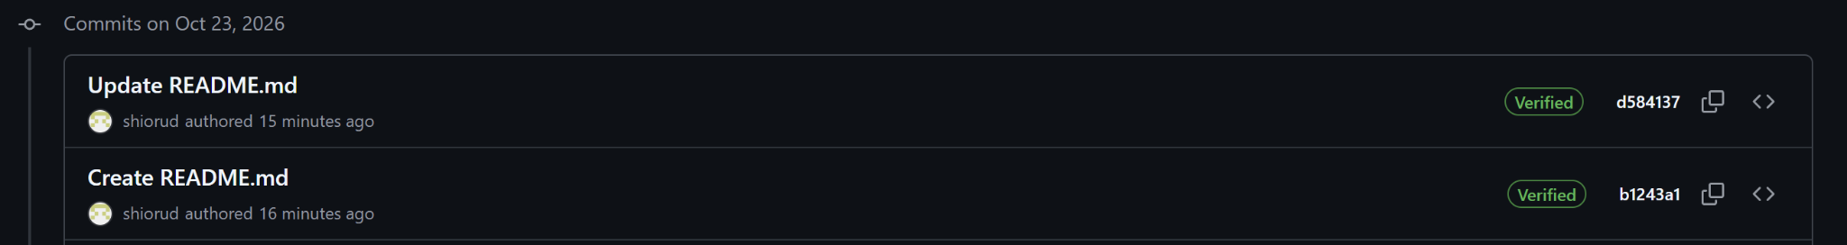
Ex.2.1
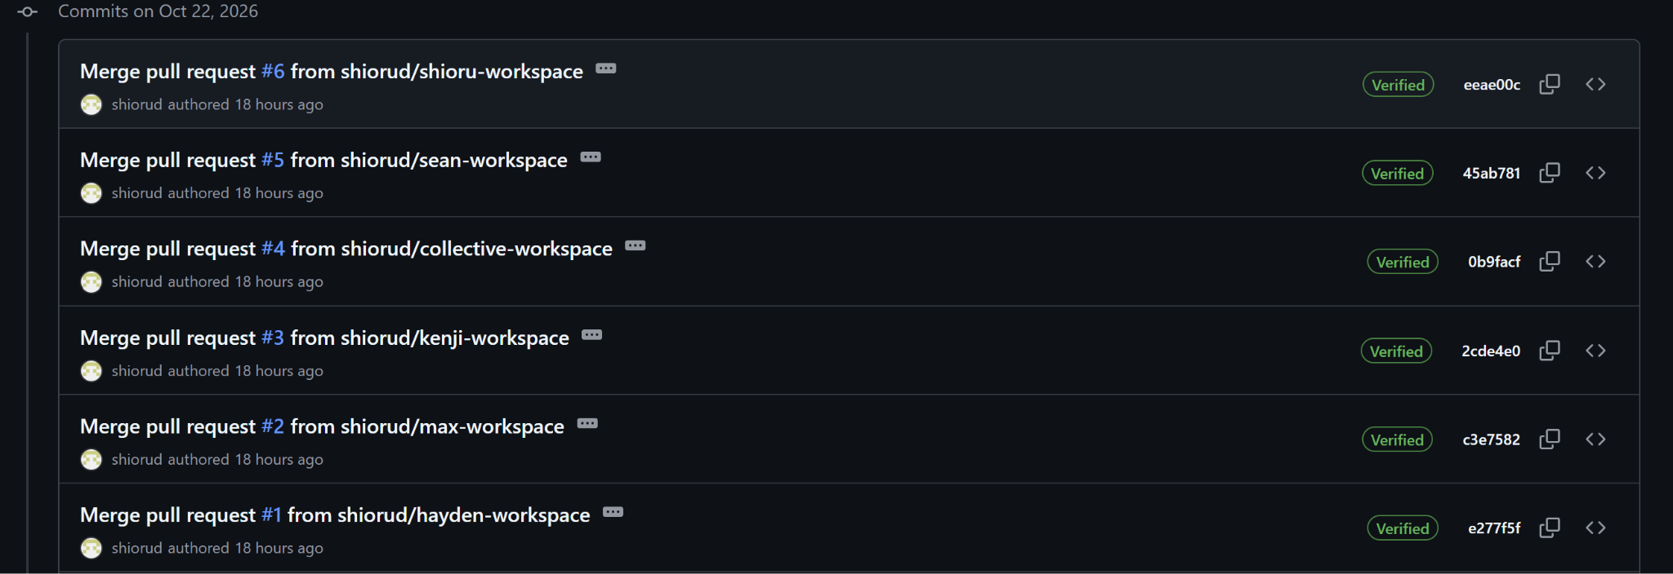
Ex.2.2

